InferenceProject
Charles Kirk
2024-11-21
library(infer)
library(tidyverse)
## ── Attaching core tidyverse packages ──────────────────────── tidyverse 2.0.0 ──
## ✔ dplyr 1.1.4 ✔ readr 2.1.5
## ✔ forcats 1.0.0 ✔ stringr 1.5.1
## ✔ ggplot2 3.5.1 ✔ tibble 3.2.1
## ✔ lubridate 1.9.3 ✔ tidyr 1.3.1
## ✔ purrr 1.0.2
## ── Conflicts ────────────────────────────────────────── tidyverse_conflicts() ──
## ✖ dplyr::filter() masks stats::filter()
## ✖ dplyr::lag() masks stats::lag()
## ℹ Use the conflicted package (<http://conflicted.r-lib.org/>) to force all conflicts to become errors
library(readr)
library(moderndive)
library(effsize)
pres <- read_csv("~/Dropbox/Charley/Juniata/Data Science Masters/Statistics Fundamentals/CleanBloodpressuredata.csv")
## Rows: 3670 Columns: 19
## ── Column specification ────────────────────────────────────────────────────────
## Delimiter: ","
## chr (9): BP, BPStatus, BMICategory, Gender, DiagnosedDiabetic, TobaccoUser,...
## dbl (10): OVERALL, YEAR, REC, BPRatio, Systolic, Diastolic, Age, Weight, Hei...
##
## ℹ Use `spec()` to retrieve the full column specification for this data.
## ℹ Specify the column types or set `show_col_types = FALSE` to quiet this message.
pres<-pres%>%
select(-REC, -Date)
Introduction
This dataset comes from an assignment in Data Science Fundamentals where we cleaned up a dataset of data on fair attendees. The data I used to create the presdat dataframe is a cleaned csv version of the Bloodpressuredata.xlsx document from that assignment. I believe the original source was given to be JC Blair Hospital, apparently renamed Penn Highlands Huntingdon. The hospital collected this data from people at the Huntingdon County Fair. The data may have been collected by survey but I don’t think I have access to the original survey questions. There may be a lot of NAs in the data that get filtered out as I perform hypothesis tests and construct confidence intervals, so I might not be working with subsets that are super representative of the population. The population of interest is the attendees of the Huntingdon County Fair.
My CleanBloodpressuredata csv contained 19 columns but I selected just 17 for this project, omitting REC and Date.
Variables: OVERALL: Case ID variable. YEAR: The year the individual’s data was recorded. BP: The blood pressure of the individual; I think it’s computed as Systolic/Diastolic though it may not be directly derived from the Systolic and Diastolic in this dataset. BPRatio:The individual’s BP given as a decimal. Systolic: In the HospitalDataCleaning.Rmd document it was described as “the top number in blood pressure.” Diastolic: In the HospitalDataCleaning.Rmd document it was described as “the bottom number in blood pressure.” BPStatus: Low, Normal, Pre-Hypertension or Hypertension. Age: The age of the individual in years. Weight: The weight of the individual in pounds. HeightInches: The height of the individual in inches. BMI: Computed based on the height and weight of the individual. BMICategory: Normal, Overweight or Obese. Gender: The gender of the individual, with values of M and F. DiagnosedDiabetic: Y if the individual was ever diagnosed with diabetes, N if they were not. TobaccoUser: Y if the individual uses tobacco, N if they do not. OnmedicationforBP: Y if the individual is on medication for high blood pressure, N if they are not. HuntingdonCountyResident: Y if the individual is a resident of Huntingdon County, N if they are not.
Here I perform some additional cleaning of my data.
pres<-pres%>%
mutate(DiagnosedDiabetic=fct_recode(DiagnosedDiabetic, Y="Gestational Diabetes", Y="During Pregnancy", N="Borderline", N="Pre-Diabetic"), BPStatus=fct_recode(BPStatus, NULL="N/A", NULL="NA", Other="Optimal"), OnmedicationforBP=fct_recode(OnmedicationforBP, NULL="N/A"), TobaccoUser=fct_recode(TobaccoUser, NULL="N/A", N='M'))%>%
filter(is.na(OnmedicationforBP)==TRUE | OnmedicationforBP!='128')
pres
## # A tibble: 3,669 × 17
## OVERALL YEAR BP BPRatio Systolic Diastolic BPStatus Age Weight
## <dbl> <dbl> <chr> <dbl> <dbl> <dbl> <fct> <dbl> <dbl>
## 1 1 2007 147/84 1.75 147 84 Hypertension 51 201
## 2 2 2007 133/78 1.71 133 78 Pre-Hypertension 49 155
## 3 3 2007 143/89 1.61 143 89 Hypertension NA NA
## 4 4 2007 156/68 2.29 156 68 Hypertension NA NA
## 5 5 2007 147/92 1.60 147 92 Hypertension NA NA
## 6 6 2007 130/88 1.48 130 88 Pre-Hypertension NA NA
## 7 7 2007 122/65 1.88 122 65 Normal NA NA
## 8 8 2007 148/78 1.90 148 78 Hypertension 74 206
## 9 9 2007 152/86 1.77 152 86 Hypertension 48 185
## 10 10 2007 138/49 2.82 138 49 Pre-Hypertension 78 125
## # ℹ 3,659 more rows
## # ℹ 8 more variables: HeightInches <dbl>, BMI <dbl>, BMICategory <chr>,
## # Gender <chr>, DiagnosedDiabetic <fct>, TobaccoUser <fct>,
## # OnmedicationforBP <fct>, HuntingdonCountyResident <chr>
Confidence Intervals
Question 1: Is there a significant difference in the average age of attendees who are diagnosed with diabetes and attendees who are not diagnosed with diabetes? To answer this question I will construct a 90% confidence interval for the difference in population means average age of attendees diagnosed with diabetes and average age of attendees not diagnosed with diabetes using the bootstrap percentile method.
pres%>%
filter(is.na(DiagnosedDiabetic)==FALSE)%>%
count(DiagnosedDiabetic)
## # A tibble: 2 × 2
## DiagnosedDiabetic n
## <fct> <int>
## 1 N 2975
## 2 Y 601
pres%>%
summarise(mean(Age, na.rm = TRUE))
## # A tibble: 1 × 1
## `mean(Age, na.rm = TRUE)`
## <dbl>
## 1 56.4
fivenum(pres$Age)
## [1] 3 46 59 69 99
pres%>%
ggplot(aes(DiagnosedDiabetic, Age))+
geom_boxplot()
## Warning: Removed 43 rows containing non-finite outside the scale range
## (`stat_boxplot()`).
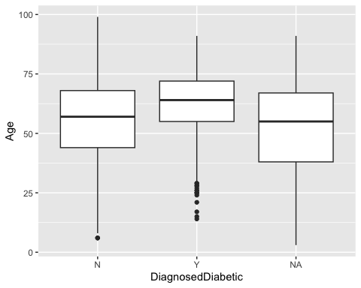
set.seed(35)
bootpres<-pres%>%
filter(is.na(DiagnosedDiabetic)==FALSE)%>%
specify(formula=Age~DiagnosedDiabetic)%>%
generate(reps=1000, type="bootstrap")%>%
calculate(stat = "diff in means", order = c("Y", "N"))
## Warning: Removed 21 rows containing missing values.
bootpres
## Response: Age (numeric)
## Explanatory: DiagnosedDiabetic (factor)
## # A tibble: 1,000 × 2
## replicate stat
## <int> <dbl>
## 1 1 7.43
## 2 2 6.05
## 3 3 6.48
## 4 4 6.21
## 5 5 6.85
## 6 6 8.42
## 7 7 7.34
## 8 8 6.20
## 9 9 7.44
## 10 10 6.64
## # ℹ 990 more rows
bootpres%>%
get_confidence_interval(level=0.9, type="percentile")
## # A tibble: 1 × 2
## lower_ci upper_ci
## <dbl> <dbl>
## 1 5.88 8.06
We used the 5th and 95th percentiles of the bootstrap distribution to construct a confidence interval. This method is appropriate because the bootstrap distribution was created with bootstrap resampling with replacement to be a simulation of the sampling distribution for the difference in means. We have 90% confidence that the interval (5.879943, 8.058591) contains the true difference in population means $μ_{Y}−μ_{N}$.
Question 2: Roughly what proportion of attendees have a “normal” blood pressure status? To answer this question I will construct a 95% confidence interval for the population proportion of attendees with a “normal” blood pressure status using the theoretical standard error method.
pres%>%
count(BPStatus)
## # A tibble: 5 × 2
## BPStatus n
## <fct> <int>
## 1 Hypertension 1023
## 2 Normal 663
## 3 Other 900
## 4 Pre-Hypertension 637
## 5 <NA> 446
pres%>%
mutate(BPStatus=fct_recode(BPStatus, Other='Hypertension', Other='Pre-Hypertension'))%>%
ggplot(aes(BPStatus))+
geom_bar()
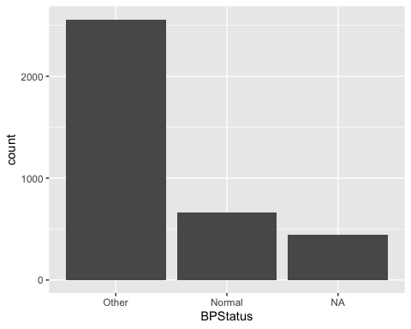
663/(900+1023+637+663)
## [1] 0.205709
proportion<-pres%>%
mutate(BPStatus=fct_recode(BPStatus, Other='Hypertension', Other='Pre-Hypertension'))%>%
filter(is.na(BPStatus)==FALSE)%>%
specify(response = BPStatus, success = "Normal")%>%
calculate(stat = "prop")
proportion
## Response: BPStatus (factor)
## # A tibble: 1 × 1
## stat
## <dbl>
## 1 0.206
se=sqrt((proportion*(1-proportion))/(900+1023+637+663))
lower_ci<-proportion-1.96*se
upper_ci<-proportion+1.96*se
data.frame(lower_ci, upper_ci)%>%
rename(lower_ci=stat, upper_ci=stat.1)
## lower_ci upper_ci
## 1 0.1917536 0.2196644
This method is appropriate because the expression sqrt((proportion*(1-proportion))/(900+1023+637+663)) gives an estimate of the standard error of the sampling distribution for the sample proportion, and it can be shown that 95% of values are within +-1.96 standard errors of the sample proportion. We have 95% confidence that the interval (0.1917536, 0.2196644) contains the true population proportion $p_{Normal}$.
Question 3: Is there a significant difference in the average BMI of attendees who are male and attendees who are female? To answer this question I will construct a 95% confidence interval for the difference in population means average BMI of attendees who are male and average BMI of attendees who are female using the bootstrap standard error method.
pres%>%
count(Gender)
## # A tibble: 3 × 2
## Gender n
## <chr> <int>
## 1 F 1788
## 2 M 1338
## 3 <NA> 543
pres%>%
filter(is.na(BMI))
## # A tibble: 1,465 × 17
## OVERALL YEAR BP BPRatio Systolic Diastolic BPStatus Age Weight
## <dbl> <dbl> <chr> <dbl> <dbl> <dbl> <fct> <dbl> <dbl>
## 1 3 2007 143/89 1.61 143 89 Hypertension NA NA
## 2 4 2007 156/68 2.29 156 68 Hypertension NA NA
## 3 5 2007 147/92 1.60 147 92 Hypertension NA NA
## 4 6 2007 130/88 1.48 130 88 Pre-Hypertensi… NA NA
## 5 7 2007 122/65 1.88 122 65 Normal NA NA
## 6 12 2007 134/46 2.91 134 46 Pre-Hypertensi… NA NA
## 7 13 2007 152/73 2.08 152 73 Hypertension NA NA
## 8 17 2007 137/76 1.80 137 76 Pre-Hypertensi… NA NA
## 9 25 2007 201/127 NA NA 127 Hypertension 56 NA
## 10 28 2007 150/98 1.53 150 98 Hypertension 67 NA
## # ℹ 1,455 more rows
## # ℹ 8 more variables: HeightInches <dbl>, BMI <dbl>, BMICategory <chr>,
## # Gender <chr>, DiagnosedDiabetic <fct>, TobaccoUser <fct>,
## # OnmedicationforBP <fct>, HuntingdonCountyResident <chr>
pres%>%
summarise(mean(BMI, na.rm = TRUE))
## # A tibble: 1 × 1
## `mean(BMI, na.rm = TRUE)`
## <dbl>
## 1 29.1
fivenum(pres$BMI)
## [1] 13.73649 24.95858 28.33916 32.26015 70.52594
pres%>%
ggplot(aes(Gender, BMI))+
geom_boxplot()
## Warning: Removed 1465 rows containing non-finite outside the scale range
## (`stat_boxplot()`).
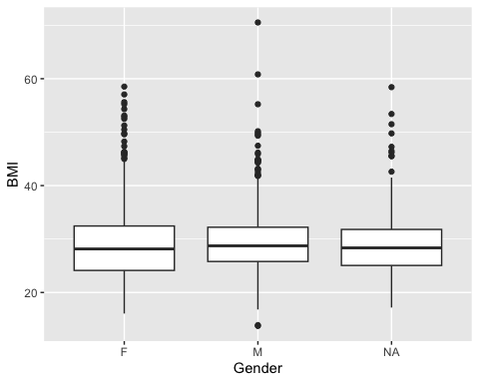
set.seed(84)
bootpres2<-pres%>%
filter(is.na(Gender)==FALSE)%>%
specify(formula=BMI~Gender)%>%
generate(reps=1000, type="bootstrap")%>%
calculate(stat = "diff in means", order = c("M", "F"))
## Warning: Removed 1231 rows containing missing values.
bootpres2%>%
ggplot(aes(stat))+
geom_histogram()
## `stat_bin()` using `bins = 30`. Pick better value with `binwidth`.
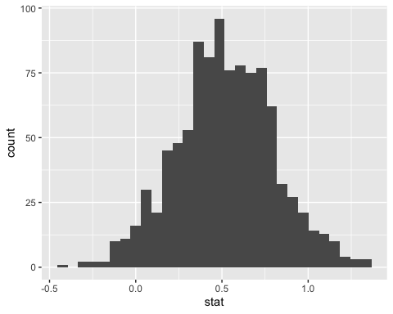 The distribution looks relatively bell-shaped.
point_estimate<-pres%>%
filter(is.na(Gender)==FALSE)%>%
specify(formula=BMI~Gender)%>%
calculate(stat = "diff in means", order = c("M", "F"))
## Warning: Removed 1231 rows containing missing values.
point_estimate
## Response: BMI (numeric)
## Explanatory: Gender (factor)
## # A tibble: 1 × 1
## stat
## <dbl>
## 1 0.512
bootpres2%>%
get_confidence_interval(level=0.95, type="se", point_estimate = point_estimate)
## # A tibble: 1 × 2
## lower_ci upper_ci
## <dbl> <dbl>
## 1 -0.0425 1.07
We used the standard error of the bootstrap distribution to construct a confidence interval. This method is appropriate because the bootstrap distribution was created with bootstrap resampling with replacement to be a simulation of the sampling distribution for the difference in means, and because the distribution is relatively bell-shaped we can typically expect around 95% of values to be within +-1.96 standard errors of the point estimate. We have 95% confidence that the interval (-0.04248819, 1.06699) contains the true difference in population means $μ_{M}−μ_{F}$.
Hypothesis Tests
Question 1: Is there a significant difference in the average BP Ratio of attendees who are on medication for BP and attendees who are not on medication for BP? I will answer this question by conducting a hypothesis test using a 5% significance level and a null distribution constructed through randomization of my original sample.
pres%>%
count(OnmedicationforBP)
## # A tibble: 3 × 2
## OnmedicationforBP n
## <fct> <int>
## 1 N 2090
## 2 Y 1478
## 3 <NA> 101
pres%>%
summarise(mean(BPRatio, na.rm = TRUE))
## # A tibble: 1 × 1
## `mean(BPRatio, na.rm = TRUE)`
## <dbl>
## 1 1.77
fivenum(pres$BPRatio)
## [1] 1.060606 1.577465 1.726316 1.917808 5.566667
pres%>%
ggplot(aes(OnmedicationforBP, BPRatio))+
geom_boxplot()
## Warning: Removed 68 rows containing non-finite outside the scale range
## (`stat_boxplot()`).
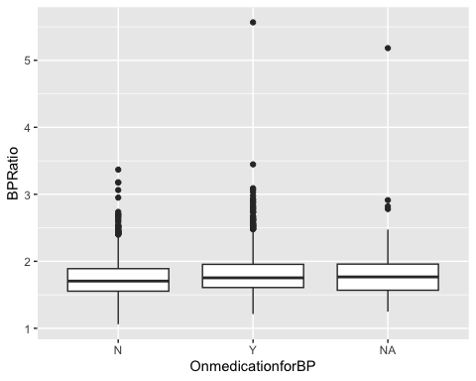
set.seed(45)
obs_diff_means<-pres %>%
filter(is.na(OnmedicationforBP)==FALSE)%>%
specify(BPRatio ~ OnmedicationforBP) %>%
calculate(stat = "diff in means", order = c("Y", "N"))
## Dropping unused factor levels 128 from the supplied explanatory variable
## 'OnmedicationforBP'.
## Warning: Removed 66 rows containing missing values.
null_distribution_BPRatio <- pres %>%
filter(is.na(OnmedicationforBP)==FALSE)%>%
specify(BPRatio ~ OnmedicationforBP)%>%
hypothesize(null = "independence") %>%
generate(reps = 5000)%>%
calculate(stat = "diff in means", order = c("Y", "N"))
## Dropping unused factor levels 128 from the supplied explanatory variable
## 'OnmedicationforBP'.
## Warning: Removed 66 rows containing missing values.
## Setting `type = "permute"` in `generate()`.
null_distribution_BPRatio%>%
get_p_value(obs_stat = obs_diff_means, direction = "both")
## Warning: Please be cautious in reporting a p-value of 0. This result is an approximation
## based on the number of `reps` chosen in the `generate()` step.
## ℹ See `get_p_value()` (`?infer::get_p_value()`) for more information.
## # A tibble: 1 × 1
## p_value
## <dbl>
## 1 0
obs_diff_means
## Response: BPRatio (numeric)
## Explanatory: OnmedicationforBP (factor)
## # A tibble: 1 × 1
## stat
## <dbl>
## 1 0.0671
The mean BP Ratio of attendees who are on medication for BP in my sample was greater than the mean BP Ratio of attendees who are not on medication for BP in my sample. The p-value for this test was obtained by checking the observed difference in means for the two medication groups against a distribution that was obtained by generating samples of the original dataset with the values of OnmedicationforBP shuffled. This is appropriate because said distribution acts as a null distribution where the difference in means is 0. The p-value was approximated at 0 which is less than $α=0.05$. Given this I would reject the Null hypothesis and conclude that attendees who are on medication for BP have a higher BP Ratio than attendees who are not on medication for BP.
Question 2: Is there a significant difference in the average weight of attendees who are on medication for BP and attendees who are not on medication for BP? I will answer this question by conducting a hypothesis test using a 5% significance level and a null distribution constructed through randomization of my original sample.
pres%>%
summarise(mean(Weight, na.rm = TRUE))
## # A tibble: 1 × 1
## `mean(Weight, na.rm = TRUE)`
## <dbl>
## 1 183.
fivenum(pres$Weight)
## [1] 24 151 180 210 437
pres%>%
ggplot(aes(OnmedicationforBP, Weight))+
geom_boxplot()
## Warning: Removed 404 rows containing non-finite outside the scale range
## (`stat_boxplot()`).
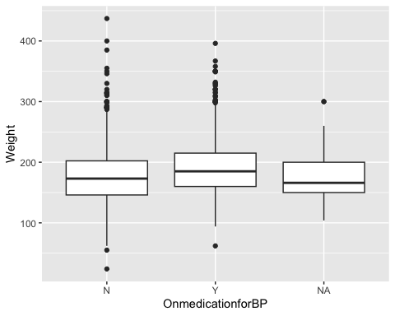
set.seed(83)
obs_diff_means<-pres %>%
filter(is.na(OnmedicationforBP)==FALSE)%>%
specify(Weight ~ OnmedicationforBP) %>%
calculate(stat = "diff in means", order = c("Y", "N"))
## Dropping unused factor levels 128 from the supplied explanatory variable
## 'OnmedicationforBP'.
## Warning: Removed 366 rows containing missing values.
null_distribution_Weight <- pres %>%
filter(is.na(OnmedicationforBP)==FALSE)%>%
specify(Weight ~ OnmedicationforBP)%>%
hypothesize(null = "independence") %>%
generate(reps = 5000)%>%
calculate(stat = "diff in means", order = c("Y", "N"))
## Dropping unused factor levels 128 from the supplied explanatory variable
## 'OnmedicationforBP'.
## Warning: Removed 366 rows containing missing values.
## Setting `type = "permute"` in `generate()`.
null_distribution_Weight%>%
get_p_value(obs_stat = obs_diff_means, direction = "both")
## Warning: Please be cautious in reporting a p-value of 0. This result is an approximation
## based on the number of `reps` chosen in the `generate()` step.
## ℹ See `get_p_value()` (`?infer::get_p_value()`) for more information.
## # A tibble: 1 × 1
## p_value
## <dbl>
## 1 0
obs_diff_means
## Response: Weight (numeric)
## Explanatory: OnmedicationforBP (factor)
## # A tibble: 1 × 1
## stat
## <dbl>
## 1 13.3
The mean weight of attendees who are on medication for BP in my sample was greater than the mean weight of attendees who are not on medication for BP in my sample. The p-value for this test was obtained by checking the observed difference in means for the two medication groups against a distribution that was obtained by generating samples of the original dataset with the values of OnmedicationforBP shuffled. This is appropriate for the same reason as in the last hypothesis test, because said distribution acts as a null distribution where the difference in means is 0. The p-value was approximated at 0 which is less than $α=0.05$. Given this I would reject the Null hypothesis and conclude that attendees who are on medication for BP have a higher weight than attendees who are not on medication for BP.
Question 3: Is there a significant difference in the average age of attendees who are tobacco users and attendees who are not tobacco users? I will use a two-sample t-test and a 5% significance level to answer this question.
pres%>%
count(TobaccoUser)
## # A tibble: 3 × 2
## TobaccoUser n
## <fct> <int>
## 1 N 3001
## 2 Y 594
## 3 <NA> 74
pres%>%
summarise(mean(Age, na.rm = TRUE))
## # A tibble: 1 × 1
## `mean(Age, na.rm = TRUE)`
## <dbl>
## 1 56.4
fivenum(pres$Age)
## [1] 3 46 59 69 99
pres%>%
ggplot(aes(TobaccoUser, Age))+
geom_boxplot()
## Warning: Removed 43 rows containing non-finite outside the scale range
## (`stat_boxplot()`).
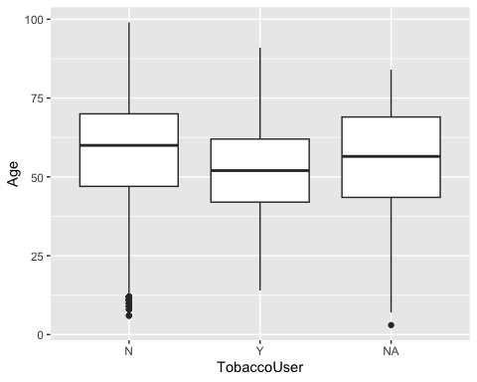
We will check for normality and equal variance.
pres%>%
filter(TobaccoUser=="Y")%>%
ggplot(aes(Age))+
geom_histogram()
## `stat_bin()` using `bins = 30`. Pick better value with `binwidth`.
## Warning: Removed 2 rows containing non-finite outside the scale range
## (`stat_bin()`).
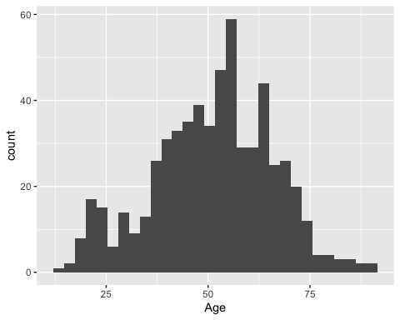
pres%>%
filter(TobaccoUser=="N")%>%
ggplot(aes(Age))+
geom_histogram()
## `stat_bin()` using `bins = 30`. Pick better value with `binwidth`.
## Warning: Removed 19 rows containing non-finite outside the scale range
## (`stat_bin()`).
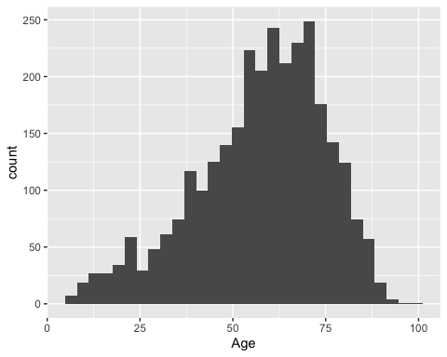
The histograms seem relatively bell-shaped.
pres %>%
filter(is.na(TobaccoUser)==FALSE)%>%
group_by(TobaccoUser) %>% summarise("standard deviation"=sd(Age, na.rm=TRUE))
## # A tibble: 2 × 2
## TobaccoUser `standard deviation`
## <fct> <dbl>
## 1 N 17.3
## 2 Y 14.8
The larger standard deviation is not more than twice the smaller standard deviation.
cohen.d(Age~ TobaccoUser, data = pres, paired = FALSE,pooled=TRUE,conf.level=0.95)
##
## Cohen's d
##
## d estimate: 0.3671545 (small)
## 95 percent confidence interval:
## lower upper
## 0.2785265 0.4557826
t.test(Age ~ TobaccoUser, data = pres,
alternative = "two.sided",
mu = 0,
var.equal = TRUE,
conf.level = 0.95)
##
## Two Sample t-test
##
## data: Age by TobaccoUser
## t = 8.1599, df = 3572, p-value = 4.597e-16
## alternative hypothesis: true difference in means between group N and group Y is not equal to 0
## 95 percent confidence interval:
## 4.724304 7.712578
## sample estimates:
## mean in group N mean in group Y
## 57.45070 51.23226
I used a two-tailed independent (unpaired) t test to test the Null Hypothesis that there was no relationship between tobacco use of an attendee and the age of an attendee at the population level. The age was greater for attendees who did not use tobacco ( x-bar = 57.45070, SD = 17.32171) than for attendees who did use tobacco ( x-bar = 51.23226, SD = 14.84427). The difference between means was small (Cohen’s d = 0.3671545). The p-value is 4.597e-16 and is less than $α$ = 0.05 (t = 8.1599, df = 3572). There was enough evidence to reject the Null Hypothesis. I conclude from this study that there is a relationship between tobacco use of an attendee and the age of an attendee at the population level.
Inference for Regression
HeightInches_Age<-lm(HeightInches ~ Age, data = pres)
I will graph this model and check whether it meets the conditions of LINE.
pres%>%
ggplot(aes(Age, HeightInches))+
geom_point()+
geom_smooth(method = "lm", se = FALSE)
## `geom_smooth()` using formula = 'y ~ x'
## Warning: Removed 820 rows containing non-finite outside the scale range
## (`stat_smooth()`).
## Warning: Removed 820 rows containing missing values or values outside the scale range
## (`geom_point()`).
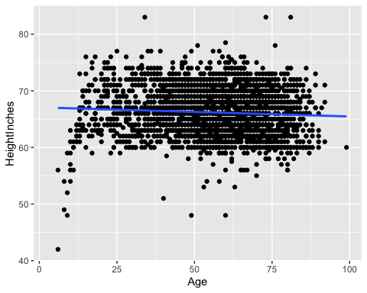 The relationship between Age and HeightInches does not appear to be obviously nonlinear.
Regarding the independence condition of LINE, each row in the pres dataframe should in theory represent a unique attendee of the Huntingdon County Fair.
get_regression_points(HeightInches_Age)%>%
ggplot(aes(residual))+
geom_histogram()
## `stat_bin()` using `bins = 30`. Pick better value with `binwidth`.
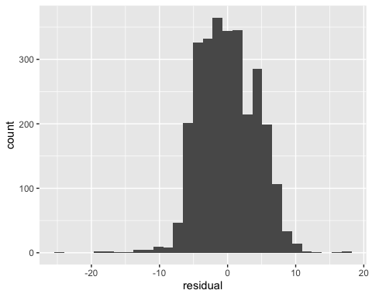 This histogram seems to be relatively bell-shaped and centered on 0.
get_regression_points(HeightInches_Age)%>%
ggplot(aes(Age, residual))+
geom_point()
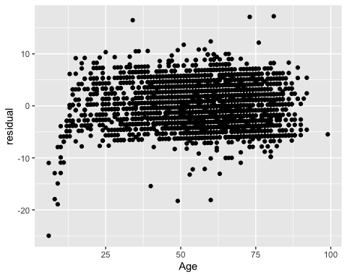 This first residual plot appears to have a relatively constant spread of residuals around the line y=0.
get_regression_points(HeightInches_Age)%>%
ggplot(aes(HeightInches, residual))+
geom_point()
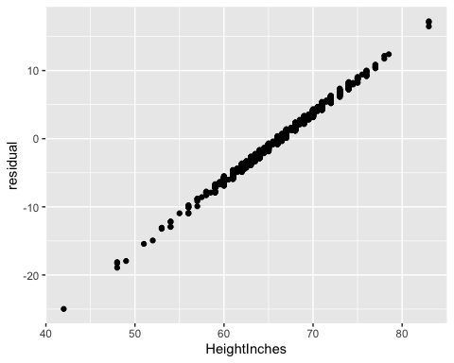 This second residual plot appears to show a strong linear trend. This could suggest that the Age variable doesn’t fully capture the variation in HeightInches.
get_regression_table(HeightInches_Age)
## # A tibble: 2 × 7
## term estimate std_error statistic p_value lower_ci upper_ci
## <chr> <dbl> <dbl> <dbl> <dbl> <dbl> <dbl>
## 1 intercept 67.1 0.271 248. 0 66.5 67.6
## 2 Age -0.016 0.005 -3.50 0 -0.025 -0.007
summary(HeightInches_Age)
##
## Call:
## lm(formula = HeightInches ~ Age, data = pres)
##
## Residuals:
## Min 1Q Median 3Q Max
## -24.9803 -3.1592 -0.1431 3.0984 17.2273
##
## Coefficients:
## Estimate Std. Error t value Pr(>|t|)
## (Intercept) 67.076890 0.270657 247.830 < 2e-16 ***
## Age -0.016101 0.004607 -3.495 0.000481 ***
## ---
## Signif. codes: 0 '***' 0.001 '**' 0.01 '*' 0.05 '.' 0.1 ' ' 1
##
## Residual standard error: 4.179 on 2847 degrees of freedom
## (820 observations deleted due to missingness)
## Multiple R-squared: 0.004272, Adjusted R-squared: 0.003923
## F-statistic: 12.22 on 1 and 2847 DF, p-value: 0.0004812
The intercept doesn’t really have a practical interpretation in this context so we can ignore it’s p-value. The p-value for the coefficient of Age is calculated as 0.000481, so at a 5% significance level we reject the null hypothesis that there is no relationship between Age and HeightInches and conclude that there is a relationship between Age and HeightInches. Also based on the values given in the lower_ci and upper_ci columns in the regression table output we can say that we are 95% confident that the interval (-0.025, -0.007) contains the true population slope $β_{1}$. This interval notably doesn’t include 0. But while I wouldn’t necessarily say that this model is invalid, I wouldn’t consider it the best model to use considering the fact that there is still a trend in the residuals that is not explained by Age and the multiple R-squared value is low at 0.004272.
Conclusion
I think a lot of my results turned out to be statistically significant, which is maybe a little surprising. It was interesting to observe that there was a statistically significant difference in the age of tobacco users and the age of tobacco users for example. That said I did unfortunately have a lot of NAs in my data so it wasn’t a perfect sample. Regarding the linear model I created, I wasn’t quite sure what to make of the second residual plot. Even if the model was a bad fit, I’m not sure why I would observe such a strong positive linear trend in the residuals like that. Maybe there’s another variable that explains a lot of the variation in HeightInches, one that might not even be present in the dataset?

